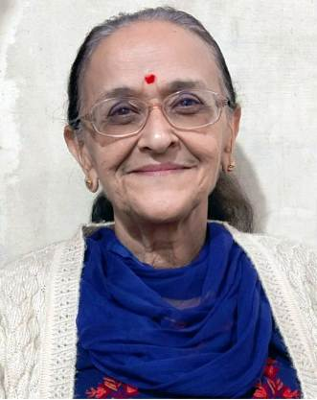
Dr. Neeta Khanna
Associate Professor and Head of the Department
Email:neetakhanna9@gmail.com
Official Email: neetakhanna9@gmail.com
Mobile No: 94180-90549

EDUCATIONAL QUALIFICATIONS: M.A , M. Ed PhD

Sr. No. | Degree | Subject | College/University | Year of Passing
1 | B.A | English History Political Science | HPU Shimla | 1972
2 | M.A | English | HPU Shimla | 1976
3 | B. Ed | Education | Annamalai University | 1989
4 | M. Ed | Education | HPU Shimla | 1990
5 | Ph.D | Education | HPU Shimla | 1998

TOTAL TEACHING EXPERIENCE:
47years Teaching Experience at St. Bede’s College:

RESEARCH EXPERIENCE: Major/Minor Project

SUBJECTS TAUGHT

UG: Principles of Education, School Management & Methods of English, ------------
OTHER RESPONSIBILITIES
Incharge: Prayer Service

